Found this procedure on another site while searching after I found Jscan will allow this procedure to be completed.
Perform ABS Brake Bleed Procedure
So now we're ready to perform the ABS Brake Module Bleed using OBD Jscan app.
Note from original poster: This is a 2 person job, where one person will need to hold the Brake pedal while the other opens the bleeder valves. It is likely not a good idea to attempt to wedge something in your JK to hold the brake pedal down for you. During this procedure, the ABS module will pump the brakes and when it does so, it will push the brake pedal upwards. The less air which is in the system, the harder that push force upwards will become where there may be a risk of damage to your interior if you tried to wedge something in there to hold the pedal down for you.
Note from brandofamily: I used a Brake Pedal Depressor Tool to hold the pedal and it worked fine.
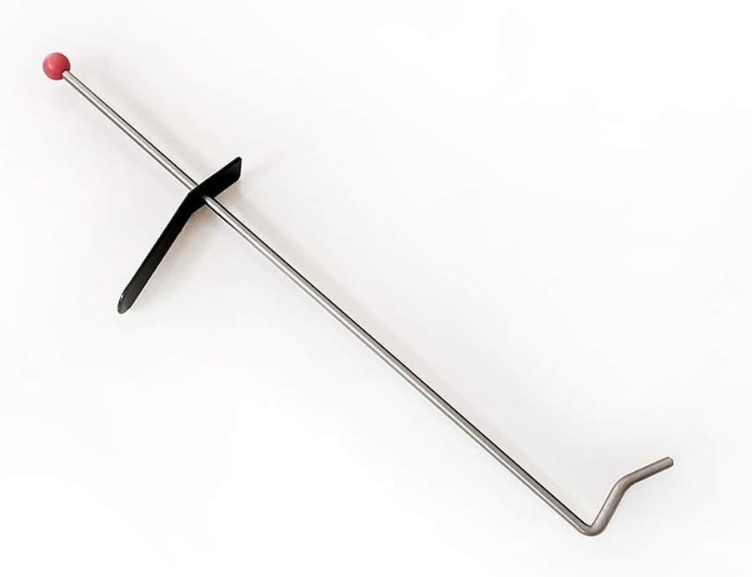
Perform ABS Brake Bleed:
1. In Jscan, select the "Adaptation" tab
2. Then select "Vehicle Maintenance" (You may have to scroll down to find it)

3. Select "ABS Brake Pump Bleed"

4. Warning Message, follow instructions and Press "Go"

5. Warning Message Press "Go" (completed in Pre Setup)

6. Warning Message Press "Go" (Completed in Pre Setup)

*Tip: If you see a communications error message after pressing "Go", then follow steps below in Communications Error section to fix.
7. Have your assistant press and hold down the Brake Pedal
*Tip: If your brake pedal is soft, it is best to have them quickly pump the brake pedal 3-5 times to build up some pressure in the brake lines so the pedal becomes firm and then hold the Brake pedal down

8. The ABS Brake Bleed Procedure will now start!
Tip1: The First part of the procedure Jscan will activate your ABS Module. Your assistant will feel your brake pedal pushing upwards against their foot, it will do this ABS Module pumping about 4 times about 1.5 seconds apart during each pump. Just have them continue to hold their foot firmly against the pedal during this pumping action.
Tip2: If you were concerned that your ABS module needed to be replaced, this is a great test sanity check. The ABS module is made up of 2 sections. One of the sections is the electronic control section(the black half) which operates 12 electrically operated piston switches inside of it. The second half is the mechanical half which has the DC motor pump and where the Pistons switches open/close into. If your assistant is feeling the pumping action against their foot, then this means the module is being electronically activated, and creating the pumping action(ie both sections are functioning). What we likely don't know at this point, is if all 12 of the pistons are moving as they should? However, if you are not feeling any pumping during this stage then this likely means you may need to replace your ABS module but lets continue with the bleed procedure to find out more.

9. Make your way over to the Driver side Front brake with your 11mm wrench and get prepared to open the bleeder valve to let air out of the system.
When JScan finishes the operation in step #8 above, the following screen will be displayed.
Tip: DO NOT OPEN THE BLEEDER VALVE AS THE INSTRUCTIONS STATE AT THIS POINT! This is very important, I learned from experience. You will get very little air out of the system following these instructions exactly.

10. Press the "Go" button above and then Jscan will display the following Screen
Tip: There isn't any test in progress when this screen is displayed. However it is time to get your 11mm wrench on that bleeder valve and get prepared to crack it open. When you press the "Go" button, JScan will immediately kick off the ABS pump to start pumping air out of the module.

11. With your 11mm wrench on the bleeder valve press the "Go" button above.
12. JScan will now activate the ABS module, followed by 4 consecutive ABS pumps which are 1.6 seconds apart.
13. Let Jscan perform the 1st pump with the bleeder valve closed.
Tip: With the bleeder valve closed during the 1st pump, this will pressurize the brake system and push any air in the system closer to the caliper bleeder valve.
After the 1st pump, Jscan will display the following screen which is a countdown before it moves onto the 2nd ABS pump action.

14. With your 11mm wrench on the bleeder valve, wait for Jscan to start the 2nd cycle ABS module pump action.
Once the 2nd pump begins, then crack the bleeder valve open 1/2 of a turn, to let the air combined with brake fluid out of the system.
15. Leave the bleeder valve open as Jscan continues with the consecutive pump actions, observing through the clear tube of your Brake Bleeder tool if air bubbles are exiting mixed with brake fluid.
16. Once Jscan completes the 4th ABS pumping action, immediately close the bleeder valve when the screen below appears.
Tip: As described previously the ABS module has 12 piston switches. There are 3 piston switches for each wheel. If you observed fluid being pushed out during steps 14&15, then congratulations! You just confirmed those 3 piston valves are functioning properly in your ABS module!
If you didn't observe fluid being pushed out then sorry, you may have just confirmed your ABS module needs to be replaced

17. Press the "Go" button above. Grab your Brake Bleeder tool , along with your 10mm Wrench and move to the Driver side REAR wheel. Also instruct your assistance to continue holding down the brake pedal.
18. Connect your Brake Bleeder tool to the Driver Side Rear bleeder valve
19. At this point Jscan will be displaying the following screen.
Tip: Again VERY IMPORTANT! Do NOT open the bleeder valve at this step.

20. Press the "Go" button above and then Jscan will display the following Screen
Tip: There isn't any test in progress when this screen is displayed. However it is time to get your 10mm wrench on that rear bleeder valve and get prepared to crack it open. When you press the "Go" button, JScan will immediately kick off the ABS pump to start pumping air out of the module.

21. With your 10mm wrench on the bleeder valve press the "Go" button above.
22. JScan will now activate the ABS module, followed by 4 consecutive ABS pumps which are 1.6 seconds apart.
23. Let Jscan perform "2" consecutive pumps with the bleeder valve closed.
Tip: With the bleeder valve closed during the 2 consecutive pumps, this will pressurize the brake system and push any air in the system closer to the rear caliper bleeder valve.
After the 2nd pump, Jscan will display the following screen which is a countdown before it moves onto the 3rd rear ABS pump action.

24. With your 10mm wrench on the bleeder valve, wait for Jscan to start the 3rd cycle ABS module pump action.
Once the 3rd pump begins, then crack the bleeder valve open 1/2 of a turn, to let the air combined with brake fluid out of the system.
25. Leave the bleeder valve open as Jscan continues with the consecutive pump actions, observing through the clear tube of your Brake Bleeder tool if air bubbles are exiting mixed with brake fluid.
26. Once Jscan completes the ABS pumping action, immediately close the bleeder valve when the screen below appears.
Tip: As described previously the ABS module has 12 piston switches. There are 3 piston switches for each wheel. If you observed fluid being pushed out rear bleeder during steps 24&25, then congratulations! You just confirmed those 3 piston valves are functioning properly in your ABS module!
If you didn't observe fluid being pushed out then sorry, you may have just confirmed your ABS module needs to be replaced

27. Press "Go" button above and you will see the following

28. CONGRATULATIONS! BUT YOU'RE NOT DONE YET! WE NEED TO DO THIS AGAIN ON THE PASSENGER SIDE!
However, you can tell your assistant that they can now let their foot off the brake pedal and give their leg a break.
29. At this point, go top off your Brake Fluid reservoir with more fresh brake fluid so the level is just above the max line.
Tip: You do NOT want to let the fluid run too low in the reservoir, otherwise it will draw air into the brake system and you will have to start over.
2015 Wrangler Unlimited (Tank)
Metal Cloak True Dual Rate Springs (2 1/2” lift), Superlift frt & rr adj track bars & Rancho CA bracket, Rancho 9000XL Shocks, Barnes 4WD 7075 Aluminum 1 Ton Steering Kit,
Fox® Racing Shox 985-24-145 2.0 Performance Series IFP Steering Stabilizer, NR 4x4 9/16" bolt kit, Adams 1310 Extreme Duty Driveshafts front & rear, Rear TEN Factory Chromoly Axles,
35x12.5-17 Nitto Ridge Grapplers on Willys rims w/ 1.5" wheel spacers , 4.56 gears w/ rear TruTrac, JL HD Brake Conversion w/ J8 MC Kit
SaveShare
Reply QuoteLike


brandofamily
August 2022 ROTM Winner
Joined Apr 22, 2015
4,231 Posts
Discussion starter · #2 · Aug 3, 2022 (Edited)
(Continued)
30. Goto Step #3 and perform the exact same steps on the Passenger's side.
31. Continue to perform the ABS Module Bleed procedure starting on the driver's side and ALWAYS finishing on the passenger's side until you observe absolutely no air bubbles coming through your bleeder tool's clear tubing.
32. Once you reached the point of observing no air and only fluid coming out during the bleeding procedure from ALL calipers, take your JK for a drive.
33. I would recommend to do the ABS bleed procedure on both sides one more time following your drive.
34. After all this, hopefully you're now enjoying a solid brake pedal and learned you didn't have to replace your ABS brake module.
35. Congratulations! Now you are done!
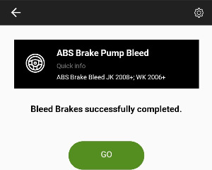
Communications ERROR FIX
If you receive a communications or other error during the ABS Module bleed procedure such as the message below then follow these steps to fix. The ABS Module is currently in a non communications state and needs to be rebooted.
Example communications Error Message
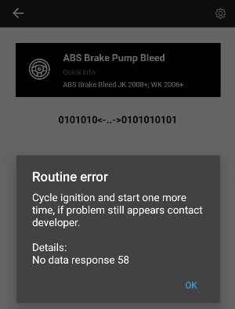
1. Press the ok button, then select the Restart all ECUs in the Jscan app
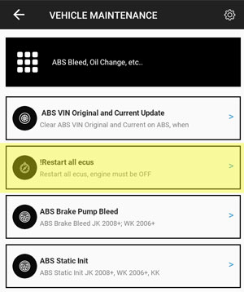
2. In the Target Value drop down, select "All modules - Power On Restart", then press the "Go" button
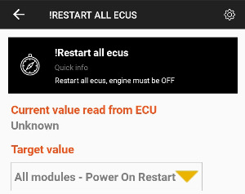
3. This procedure will take 2-3 minutes, you will see various lights on your dash turn on and off as each module is restarted. Do not interrupt this process!
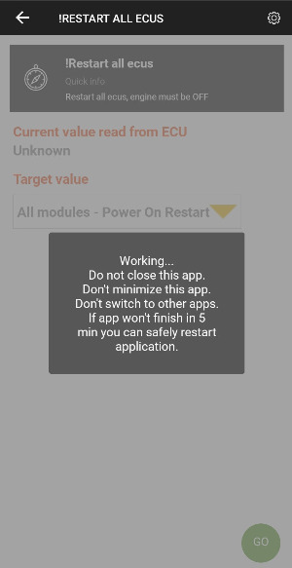
4. Once all ECUs have been restarted, you will see the follow message. Press "ok"
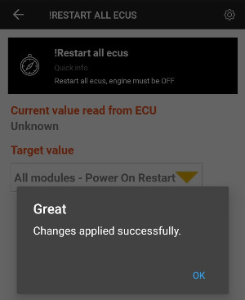
5. Once complete, go back to Step #2 in Perform ABS Brake Bleed Procedure write-up section and continue.

