Brawlee Liftgate Hatch Light Bar
2018 Jeep Wrangler JLU Installation Instructions.
Please read all instructions carefully before beginning installation.
Thank you for purchasing a Brawlee Liftgate Hatch Light Bar by Done Right Led. The staff at Done Right Led strive to offer you the best quality light bar along with ease of installation. If you have any issues with the installation process or the product itself simply contact us at Customerservice@DonerRightLed.com and we will be more than happy to help solve any issues you may have.
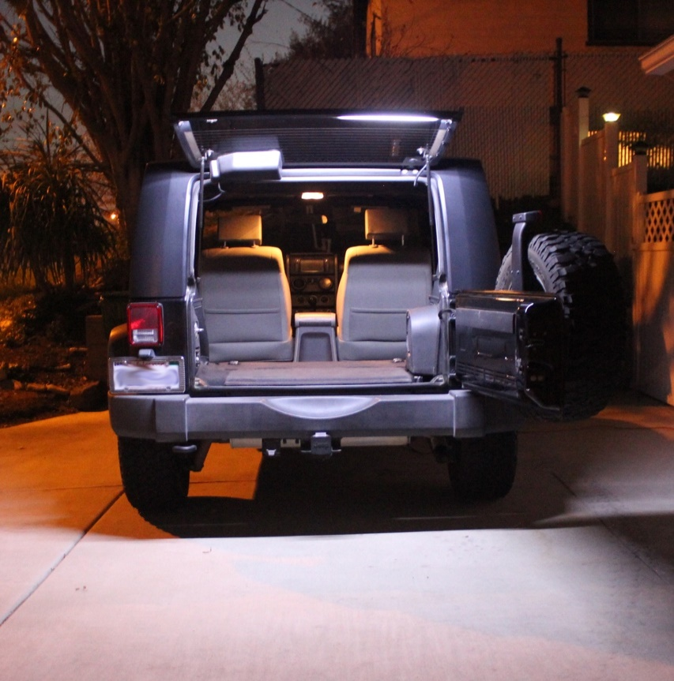
Tools required:
- Pliers, Flat blade screw driver, Torx T20 wrench
List of supplied materials:
- Brawlee LED Light Bar
- Instruction Sheet
- 1 RF controller & remote
- 1 power supply cord with DC connector
- 9 tie wraps*
- 3 wire connectors*
- 5 Black and 5 White window clips
- Adhesive backing tape (Installed on light)
- 3 alcohol wipes
- 1 ¼” x 10” split wire cover (Black)
*Note extra parts have been supplied
Estimated installation time is 60 minutes.
Installation of Brawlee Led Liftgate Hatch Light Bar.
- Locate the flat area on the lower inside edge of the liftgate glass (Photo 1). This is where you will install the light bar. Using one of the alcohol wipes supplied, thoroughly clean the entire ledge area to remove any grease or dirt that may be present. This will allow the light bar to be securely attached to the liftgate.
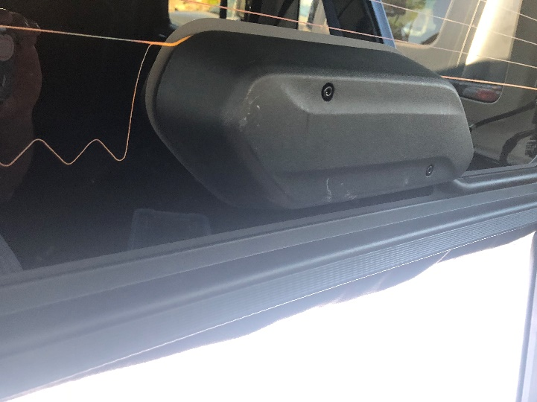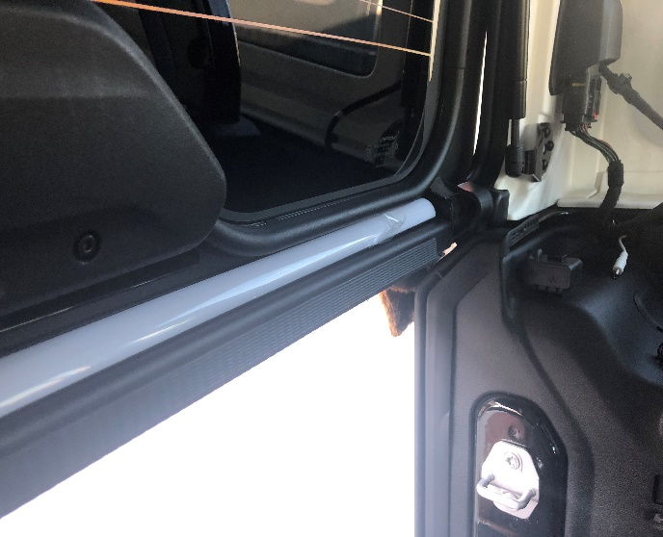
Photo 1 Photo 2
- Remove the protective covers from the double sticky tape located on the bottom side of the light bar. Install light by setting it on the small shelve and applying pressure to adhere the light securely (Photo 2). Be sure to install the light bar with the cord to the drivers side of the Jeep and the adhesive tape down since the lightbar is manufactured with a curve to match the liftgate glass.

- Use supplied alcohol wipe to clean the area along the inside passenger side of glass of grease and dirt. Install the black window clips per (Photo 3). Try to place the clips as close to the defroster as you can by following the pattern. The wire can also be routed under the plastic wire cover for a cleaner look.
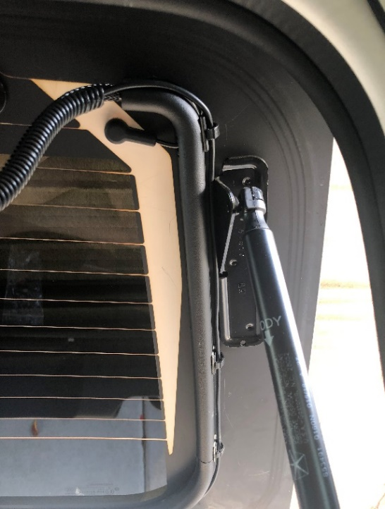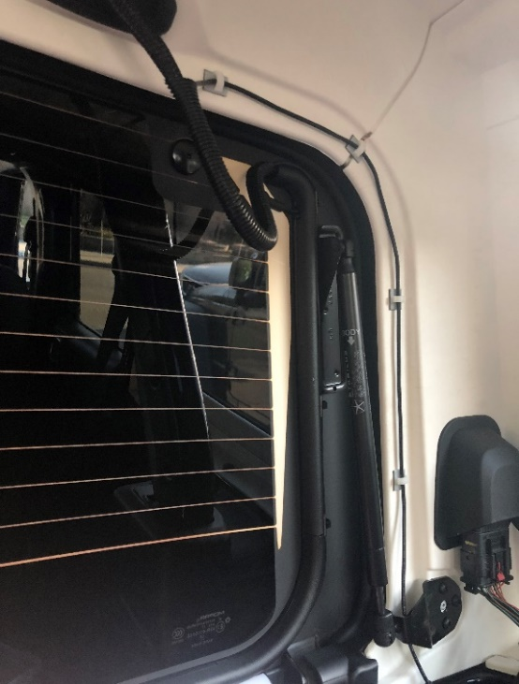
Photo 3 Photo 4
- Use supplied alcohol wipes to clean inside lip of the hardtop of grease and dirt. Install the white clips and wire to the inside of the hardtop as per the photo (Photo 4). The wire may also be routed under the rubber gasket on the hardtop for a cleaner look.

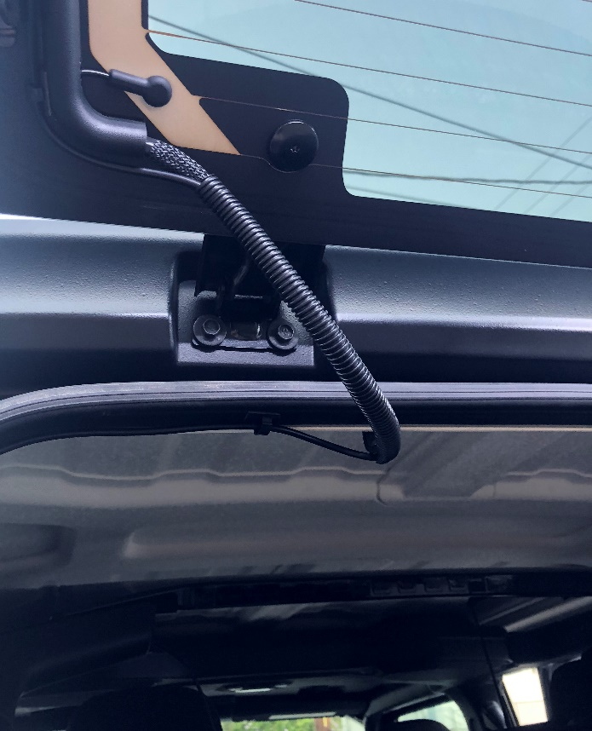
Photo 5
- Install the protective wire wrap for a clean look (Photo 5)

Installation of Wiring for 4 Door

- Pry up gently on the plastic cover around the seat belt with a flat blade screw driver until it pops loose. (Photo 6)
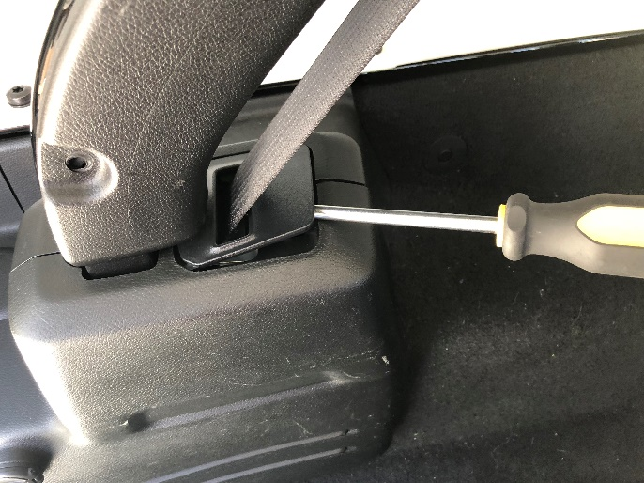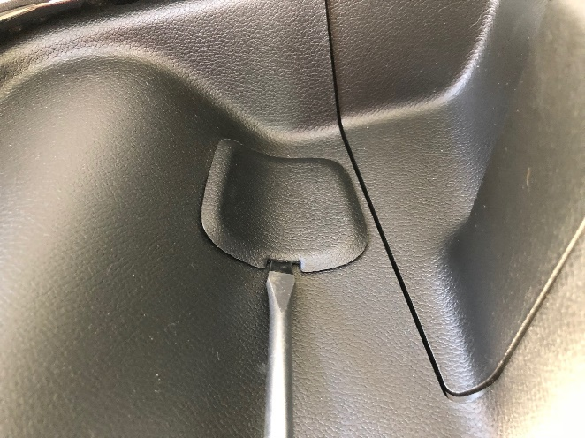
Photo 6 Photo 7
- Pry up gently on the plastic cap covering the access hole with a flat blade screwdriver and remove. (Photo 7)
Pull the plastic roll bar cover away from the side of the Jeep. The cover is held in place with clips and may take some force to get it to pop free. You do not need to remove the cover completely, just enough to gain access.

- Remove center roll bar cover by pulling firmly toward the interior of the Jeep (Photo 10)
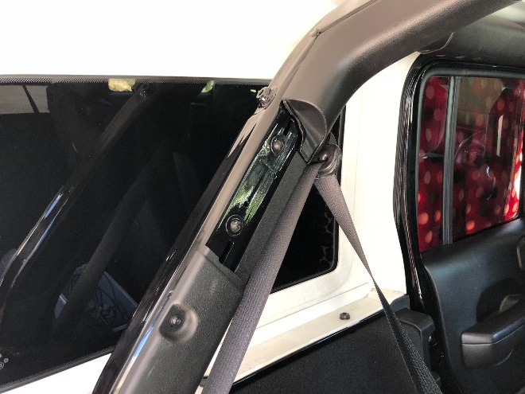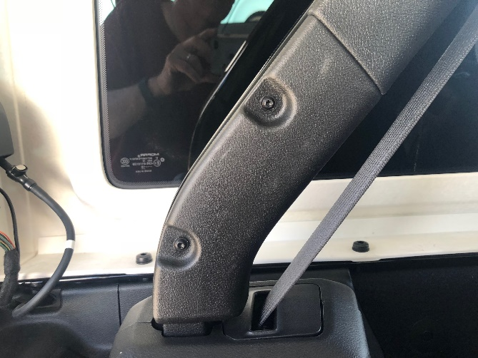
Photo 10 Photo 11
- Remove the 2 screws that hold the lower roll barc over in place and remove by pulling away from the rollbar ( Photo 11)
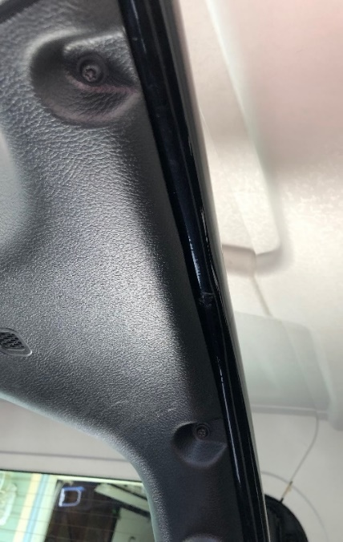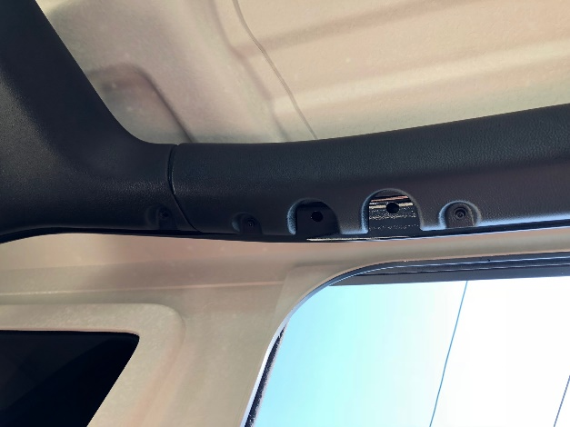
Photo 12 Photo 13
- Remove the 2 screws holding the corner roll bar cover in place. (Photo 12)
- Remove the 2 screws holding the roll bar cover over rear driver’s side door and pull down. Only pull down enough to allow the corner piece to be loosened (Photo 13)
- Remove 7 screws from placitic crossmember housing the dome light (Photo 14 and 15) and pull stright down and remove by pulling down on each end.
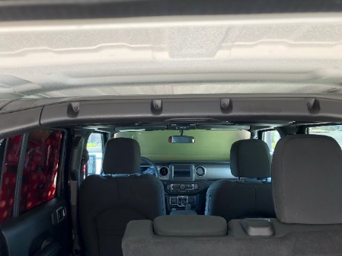
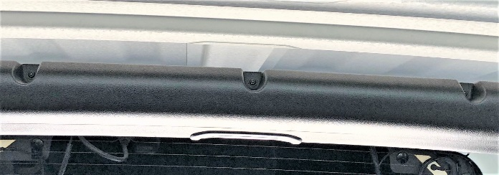

Photo 14 Photo 15
- Disconnect dome light wire by using small blade screwdriver to release locking clip.

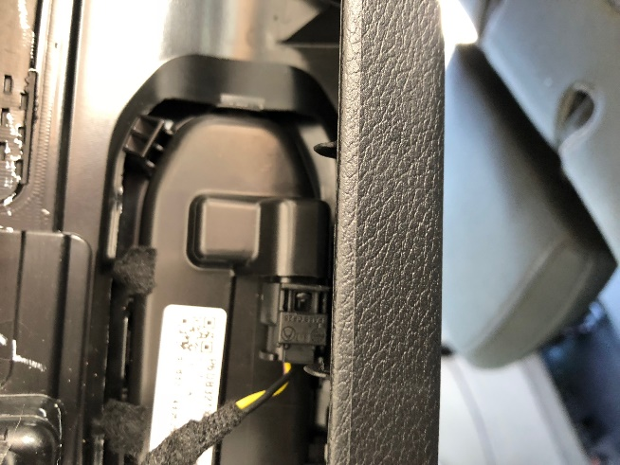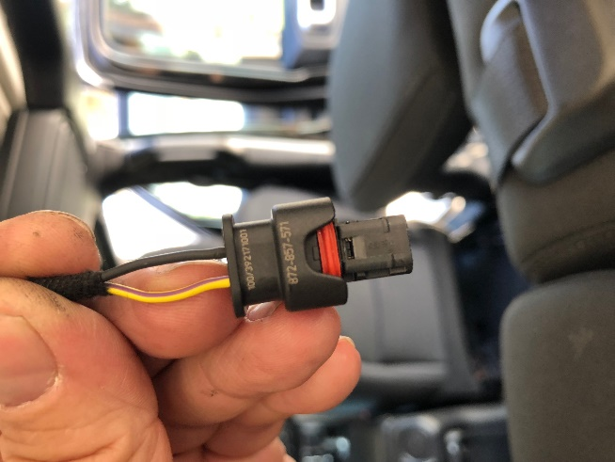
Photo 16 Photo 17
- Pull down on corner piece, You do not need to remove completely (Photo 18)
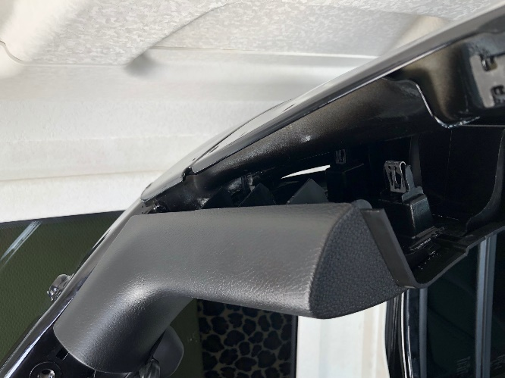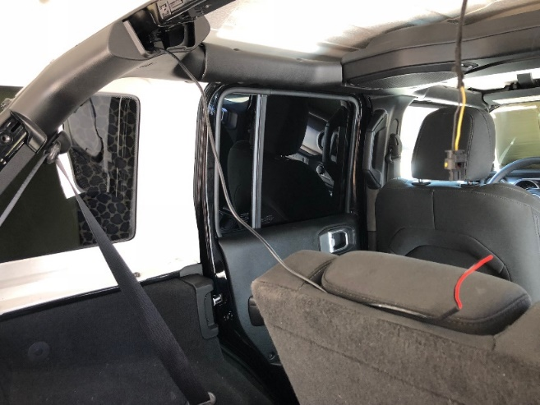
Photo 18 Photo 19
- Route power wire staring at the rear of the Jeep and following along the roll bar. (Photo 19 and 20).

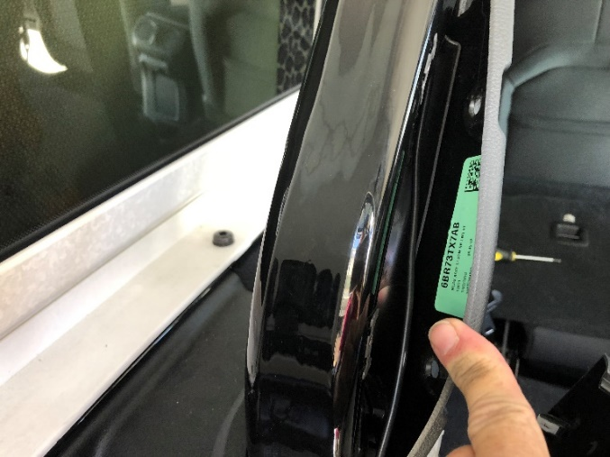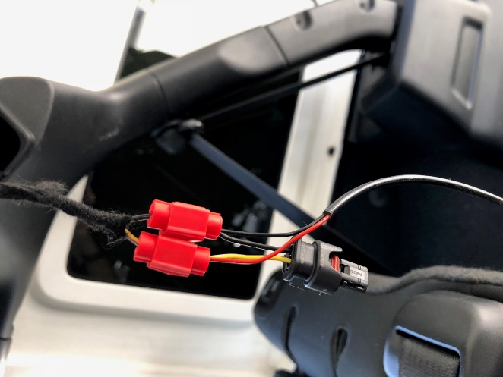
Photo 20 Photo 21
- Tap power cord to existing dome light wires. Red wire to the yellow wire. Black wire to black wire. (Photo 21)

- Reinstall all plastic roll bar covers in order they were removed. Make sure not to pinch power wire. It should move freely.

Final Assembly
- Connect the supplied RF controller to the wire connected to the dome light wiring and the other end the to your Brawlee Liftgate Hatch Led Light bar. (Photo 22) Note: the RF controller can be completely hidden behind roll bar cover for a cleaner look
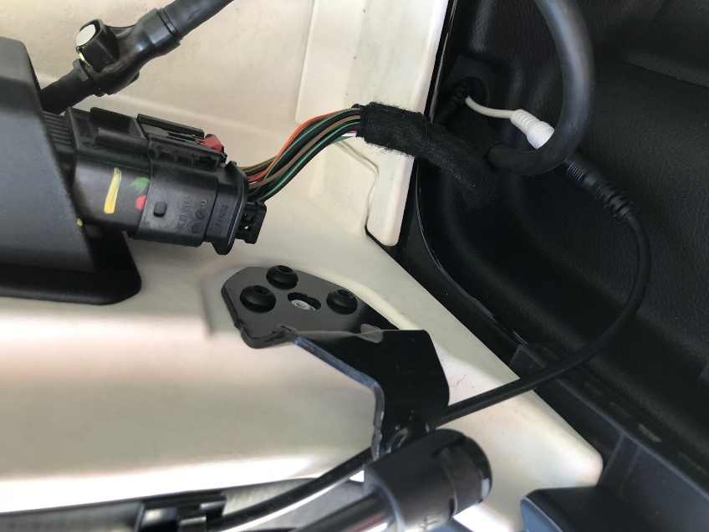
Photo 22

- Close all doors including the tailgate. This will reset the dome light. The light should come on when you open any door.

- You can now control the brightness of you Brawlee LED Liftgate Light Bar with the supplied remote. The light will stay at the setting you last used until changed.

- To remove the hardtop from your Jeep simply unplug the Brawlee Liftgate Lightbar from the RF controller. This will allow the light to be removed along with the hardtop.

- When reinstalling your hard top simply reinstall the plug into the RF plug and it is ready to use.
Again, thanks for purchasing a Brawlee Liftgate Light Bar. Every effort has been made to ensure the installation process will be as easy as possible but if for any reason, you have an issue do not hesitate to contact us at Customerservice@DoneRightLed.com. Also, be sure to like us on Facebook at Done Right LED

