- Jeep Delivery Checklist 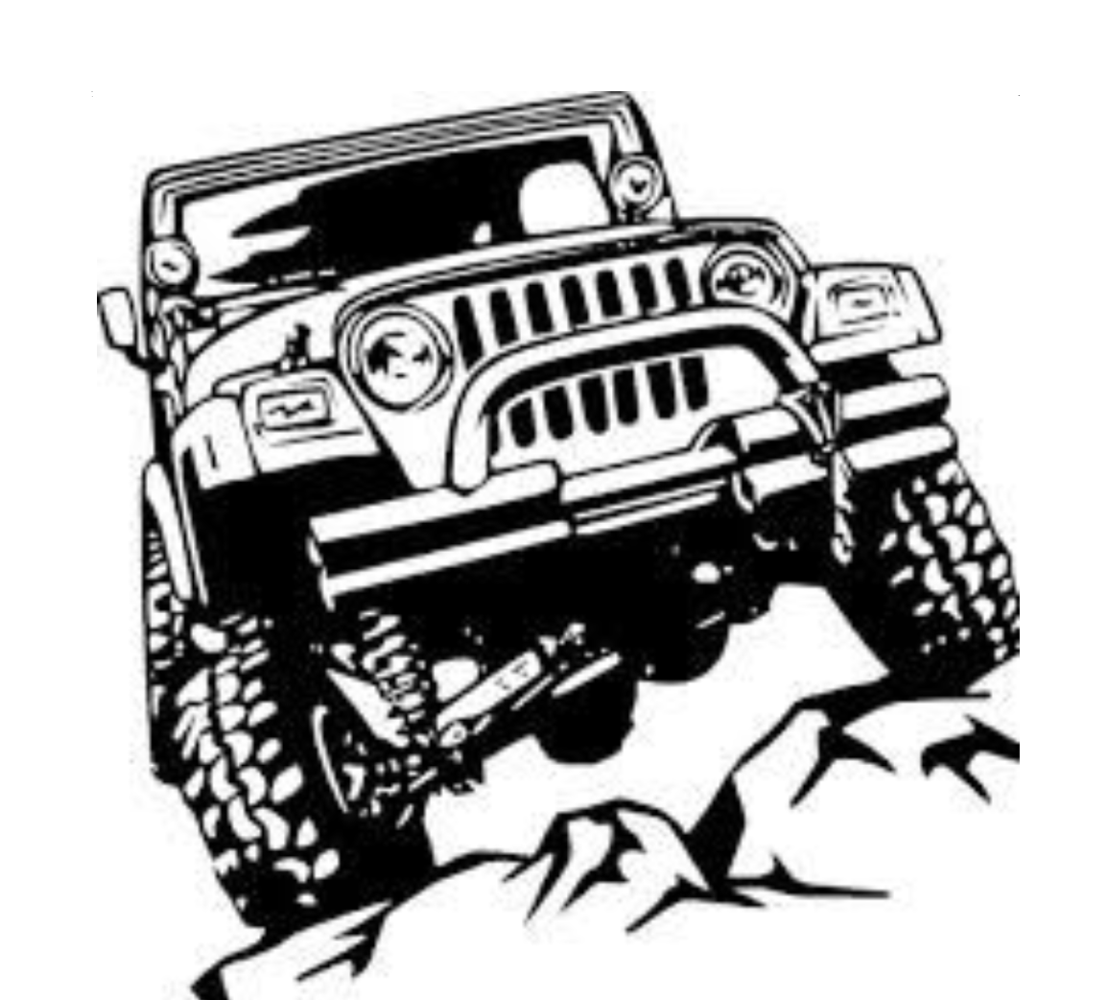
Stuff to bring for your inspection: Creeper, Flashlight, CD or phone, USB phone cord, small plug 115v light

- Verify the following properly comes with your vehicle:  - Two sets of keys  - Jeep tool kit for the right model  - Lug nut key, if applicable  - Freedom top storage bag  - Floor mats – cloth (std) or rubber depending on your options  - Owner’s manual – infotainment  - Jeep hitch receiver rubber insert for tow group  - Small baggie with tubing and splices for tow group  - Black fuel filler door on Rubicon  - 33inch BFG KM02 on Rubicon  - Rock rails on Rubicon  - _____________________________________________________  - _____________________________________________________  - _____________________________________________________  - _____________________________________________________  - _____________________________________________________  - _____________________________________________________  - _____________________________________________________ | - Verify the following are of proper quality:  - Body welds – there should be nice even heating no splatter  - Inspect undercarriage for any major rust  - Inspect for any leaks, oil, transmission, exhaust, etc.  - Inspect paint for scratches  - Check oil drain plug and oil filter for proper tightening  - Inspect tires and ensure minimal balancing weights were needed  - Shake tires and ensure minimal play in the wheels  - Inspect control arm bolts for proper torque  - Verify tire pressure at manufacturer recommended 37psi  - Inspect all seams for consistency  - Verify all fluid levels are within acceptable range  - Inspect wiring for any cuts or splices  - Verify interior is clean and no soiling has occurred from the factory  - Verify carpet is properly fastened and no signs of lifting  - Carefully inspect the paint job for imperfections – indicate to dealer  - Mileage should be under 25 miles  - _____________________________________________________  - _____________________________________________________
- Verify the following works as intended:  - Heat and AC works including fans, etc.  - Freedom Top properly removes and ensure it is properly fastened prior to leaving  - Take vehicle for a quick test drive and ensure gas, brakes, clutch, etc  - Test functionality of all options you ordered  - Inspect all lights for functionality: interior and exterior including high beams and reverse  - Windshield wipers  - No warning lights are showing once started  - Crank the engine and listen for any weird noises  - Test the horn  - Lower and Raise the windows  - Steering wheel lowers and raises and telescopes as designed  - Seats recline and easily move forward and backward  - Safety belts  - _____________________________________________________ | - Allow the salesperson to provide a full demonstration of all functionality  - Install shorty antenna – Ha you are already mod’n your Jeep!  - Install Infotainment Protector – Second mod while at dealership!  - Fill-up gas tank when you take the vehicle for a test drive  - Inquire if all recalls have been performed – such as steering prgm update  - Inspect that no dealer badges were put on your vehicle  - Insure you are given the vehicle registration and all paperwork  - Inquire as to when the title will be provided to you, if not financing  - Signed up for Jeep Wave program  - Get a schedule of all maintenance required for the vehicle over its lifetime  - Verify you are in 2Hi and drive home and enjoy your badass vehicle!  - Remember you are in the break-in period for the engine: first 60 under 50, smooth acceleration, after 60 miles up to 55mph are desirable. While cruising (high gear) brief full-throttle acceleration for a good break-in  - ________________________________________________________

