23 - Body / Interior / CONSOLE, Floor / Removal and Installation

REMOVAL AND INSTALLATION

REMOVAL
- Disconnect and isolate the negative battery cable(s) (Refer to 08 - Electrical/Battery System/Standard Procedure) .

- Remove the transfer case shifter handle (Refer to 21 - Transmission and Transfer Case/Transfer Case/HANDLE/Removal and Installation) .
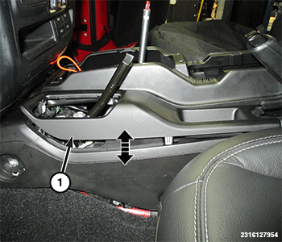

- Using a trim tool, release the retaining clips and remove the console bezel (1) for the transfer case shifter and parking brake lever.

- Remove the transmission shift knob (Refer to 21 - Transmission and Transfer Case/Automatic/SHIFTER, Transmission/Removal and Installation) .
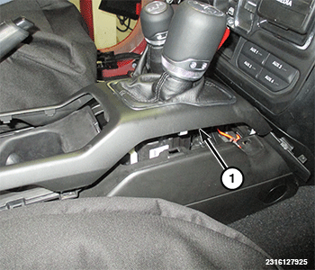

- Using a trim stick release the retaining clips and remove the console bezel (1).

- Disconnect wire harness connectors from the console bezel.
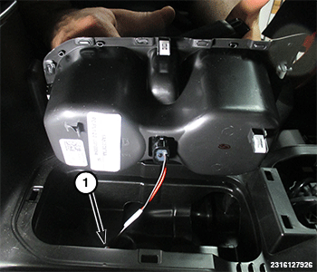

- By hand, lift upwards on the cup holder releasing it from retainers.

- Disconnect the wire harness connector (1) for the cup holder light and remove the cup holder.
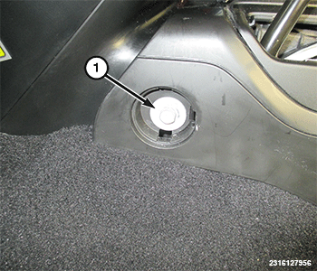

- Remove the front bolt covers and the bolts (1) on both sides of the console.

- Move the front seats to the full forward position.
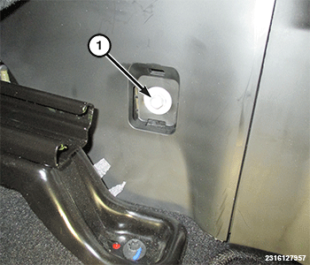

- Remove the rear bolt covers and the bolts (1) on both sides of the console.
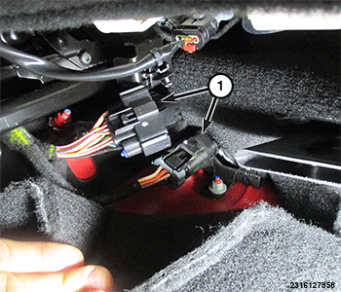

- Disconnect the wire harness connectors (1) under the rear of the front passenger seat.

- Remove the console from the vehicle with the shifter in the neutral position and lift from the back and slide out towards rear of vehicle.

INSTALLATION
- Carefully position the console into vehicle, routing the wiring harness as necessary.

- Connect the wire harness connectors (1) under the seat.

- Install the rear console bolts (1) and bolt covers.

- Move the seats to the full rearward position.

- Install the front console bolts (1) and bolt covers.

- Connect the wire harness connector (1) for the cup holder light and install cup holder.

- Install the console bezel (1).

- Install the console bezel (1) for the transfer case shifter and parking brake lever.

- Install the transmission shift knob (Refer to 21 - Transmission and Transfer Case/Automatic/SHIFTER, Transmission/Removal and Installation) .

- Install the console bezels for the transfer case and parking brake lever.

- Install the transfer case shifter handle (Refer to 21 - Transmission and Transfer Case/Transfer Case/HANDLE/Removal and Installation) .

- Connect the negative battery cable(s) (Refer to 08 - Electrical/Battery System/Standard Procedure) .

